Since 1987, the standard of Project Management has represented a process-based standard.

This standard includes project management discipline and functions around a collection of business processes. Those business processes enabled consistent and predictable practices:

1. That could be documented;
2. Though which performance against the process could be assessed;
3. Though which improvements to the process could be made to maximise efficiency and minimise threads.

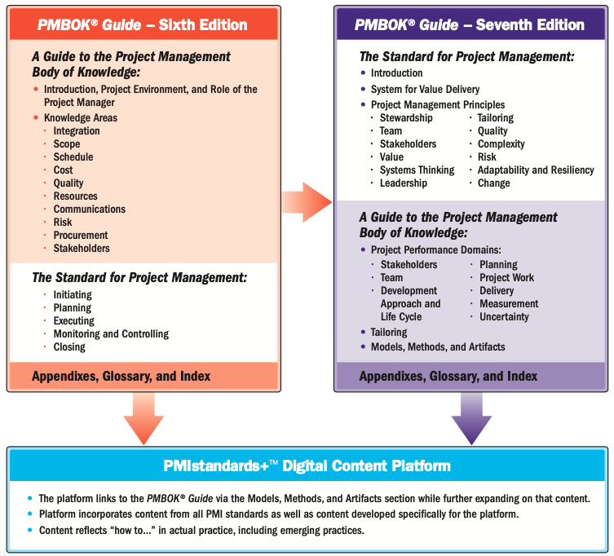

**1. Introduction 4**

1.1 Purpose of the Standard for Project Management 4

1.2 Key Terms and Concepts 4

1.3 Audience for this Standard 4

**2. A System for Value Delivery 4**

2.1 Creating Value 4

2.1.1 Value Delivery Components 4

2.1.2 Information Flow 4

2.2 Organizational Governance Systems 4

2.3 Functions Associated with Projects 4

2.3.1 Provide Oversight and Coordination 4

2.3.2 Present Objectives and Feedback 4

2.3.3 Facilitate and Support 4

2.3.4 Perform Work and Contribute Insights 4

2.3.5 Apply Expertise 4

2.3.6 Provide Business Direction and Insight 4

2.3.7 Provide Resources and Direction 4

2.3.8 Maintain Governance 5

2.4 The Project Environment 5

2.4.1 Internal Environment 5

2.4.2 External Environment 5

2.5 Product Management Considerations 5

**3. Project Management Principles 5**

3.1 Be a Diligent, Respectful, and Caring Steward 5

3.2 Create a Collaborative Project Team Environment 5

3.3 Effectively Engage with Stakeholders 5

3.4 Focus on Value 5

3.5 Recognize, Evaluate, and Respond to System Interactions 5

3.6 Demonstrate Leadership Behaviors 5

3.7 Tailor Based on Context 5

3.8 Build Quality into Processes and Deliverables 5

3.9 Navigate Complexity 5

3.10 Optimize Risk Responses 5

3.11 Embrace Adaptability and Resiliency 6

3.12 Enable Change to Achieve the Envisioned Future State 6

**1. Introduction 7**

1.1 Structure of the PMBoK Guide 7

1.2 Relationship of the PMBoK Guide and the Standard for Project Management 7

1.3 Changes to the PMBoK Guide 7

1.4 Relationship to PMIstandards+ 7

**2. Project Performance Domains 7**

2.1 Stakeholder Performance Domain 7

2.1.1 Stakeholder Engagement 7

2.1.2 Interactions with Other Performance Domains 7

2.1.3 Checking Results 7

2.2 Team Performance Domain 7

2.2.1 Project Team Management and Leadership 7

2.2.2 Project Team Culture 7

2.2.3 High-Performance Project Team 7

2.2.4 Leadership Skills 7

2.2.5 Tailoring Leadership Styles 7

2.2.6 Interactions with Other Performance Domains 7

2.2.7 Checking Results 8

2.3 Development Approach and Life Cycle 8

2.3.1 Development, Cadence, and Lift Cycle Relationship 8

2.3.2 Delivery Cadence 8

2.3.3 Development Approaches 8

2.3.4 Considerations for Selecting a Development Approach 8

2.3.5 Life Cycle and Phase Definitions 8

2.3.6 Alligning of Delevery Cadence, Development Approach, and Life Cycle 8

2.3.7 Interactions with Other Performance Domains 8

2.3.8 Measuring Outcomes 8

2.4 Planning Performance Domain 8

2.4.1 Planning Overview 8

2.4.2 Planning Variables 8

2.4.3 Project Team Composition and Structure 8

2.4.4 Communication 8

2.4.5 Physical Resources 8

2.4.6 Procurement 8

2.4.7 Changes 9

2.4.8 Metrics 9

2.4.9 Alignment 9

2.4.10 Interactions with Other Performance Domains 9

2.4.11 Checking Results 9

2.5 Project Work Performance Domain 9

2.5.1 Project Processes 9

2.5.2 Balancing Competing Constraints 9

2.5.3 Maintaining Project Team Focus 9

2.5.4 Project Communications and Engagement 9

2.5.5 Managing Physical Resources 9

2.5.6 Working with Procurements 9

2.5.7 Monitoring New Work and Changes 9

2.5.8 Learning throughout the Project 9

2.5.9 Interactions with Other Performance Domains 9

2.5.10 Checking Results 9

2.6 Delivery Performance Domain 9

2.6.1 Delivery of Value 9

2.6.2 Deliverables 9

2.6.3 Quality 10

2.6.4 Suboptimal Outcomes 10

2.6.5 Interactions with Other Performance Domains 10

2.6.6 Checking Results 10

2.7 Measurement Performance Domain 10

2.7.1 Establishing Effective Measures 10

2.7.2 What to Measure 10

2.7.3 Presenting Information 10

2.7.4 Measurement Pitfalls 10

2.7.5 Troubleshooting Performance 10

2.7.6 Growing and Improving 10

2.7.7 Interactions with Other Performance Domains 10

2.7.8 Checking Results 10

2.8 Uncertainty Performance Domain 10

2.8.1 General Uncertainty 10

2.8.2 Ambiguity 10

2.8.3 Complexity 10

2.8.4 Volatility 10

2.8.5 Risk 10

2.8.6 Interactions with Other Performance Domains 11

2.8.7 Checking Results 11

**3. Tailoring 11**

3.1 Overview 11

3.2 Why Tailor? 11

3.3 What to Tailor 11

3.3.1 Life Cycle and Development Approach Selection 11

3.3.2 Processes 11

3.3.3 Engagement 11

3.3.4 Tools 11

3.3.5 Methods and Artifacts 11

3.4 The Tailoring Process 11

3.4.1 Select Initial Development Approach 11

3.4.2 Tailor for the Organization 11

3.4.3 Tailor for the Project 11

3.5 Tailoring the Performance Domains 11

3.5.1 Stakeholders 11

3.5.2 Project Team 11

3.5.3 Development Approach and Life Cycle 12

3.5.4 Planning 12

3.5.5 Project Work 12

3.5.6 Delivery 12

3.5.7 Uncertainty 12

3.5.8 Measurement 12

3.6 Diagnostics 12

3.7 Summary 12

**4. Models, Methods, and Artifacts 12**

4.1 Overview 12

4.2 Commonly Used Models 12

4.2.1 Situational Leadership Models 12

4.2.2 Communication Models 12

4.2.3 Motivation Models 12

4.2.4 Change Models 12

4.2.5 Complexity Models 12

4.2.6 Project Team Development Models 12

4.2.7 Other Models 12

4.3 Models Applied Across Performance Domains 13

4.4 Commonly Used Methods 13

4.4.1 Data Gathering and Analysis 13

4.4.2 Estimating 13

4.4.3 Meetings and Events 13

4.4.4 Other Methods 13

4.5 Methods Applied Across Performance Domains 13

4.6 Commonly Used Artifacts 13

4.6.1 Strategy Artifacts 13

4.6.2 Logs and Registers 13

4.6.3 Plans 13

4.6.4 Hierarchy Charts 13

4.6.5 Baselines 13

4.6.6 Visual Data and Information 13

4.6.7 Reports 13

4.6.8 Agreements and Contracts 13

4.6.9 Other Artifacts 13

4.7 Artifafcts Applied Across Performance Domains 13

The Standard for Project Management

# Introduction

## 1.1 Purpose of the Standard for Project Management

## 1.2 Key Terms and Concepts

## 1.3 Audience for this Standard

# A System for Value Delivery

## 2.1 Creating Value

### 2.1.1 Value Delivery Components

### 2.1.2 Information Flow

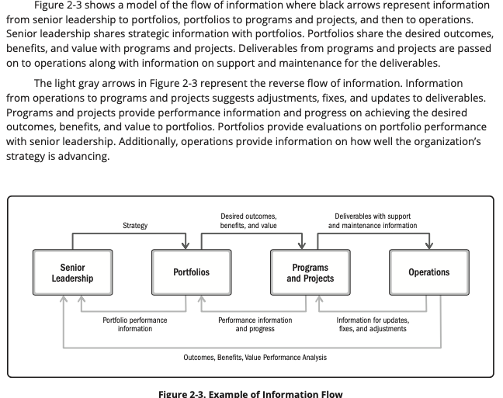

## 2.2 Organizational Governance Systems

## 2.3 Functions Associated with Projects

### 2.3.1 Provide Oversight and Coordination

### 2.3.2 Present Objectives and Feedback

### 2.3.3 Facilitate and Support

### 2.3.4 Perform Work and Contribute Insights

### 2.3.5 Apply Expertise

### 2.3.6 Provide Business Direction and Insight

### 2.3.7 Provide Resources and Direction

### 2.3.8 Maintain Governance

## 2.4 The Project Environment

### 2.4.1 Internal Environment

### 2.4.2 External Environment

## 2.5 Product Management Considerations

# Project Management Principles

## 3.1 Be a Diligent, Respectful, and Caring Steward

## 3.2 Create a Collaborative Project Team Environment

## 3.3 Effectively Engage with Stakeholders

## 3.4 Focus on Value

## 3.5 Recognize, Evaluate, and Respond to System Interactions

## 3.6 Demonstrate Leadership Behaviors

## 3.7 Tailor Based on Context

## 3.8 Build Quality into Processes and Deliverables

## 3.9 Navigate Complexity

## 3.10 Optimize Risk Responses

## 3.11 Embrace Adaptability and Resiliency

## 3.12 Enable Change to Achieve the Envisioned Future State

A Guide to the Project Management Body of Knowledge(PMBoK Guide)

# Introduction

## 1.1 Structure of the PMBoK Guide

## 1.2 Relationship of the PMBoK Guide and the Standard for Project Management

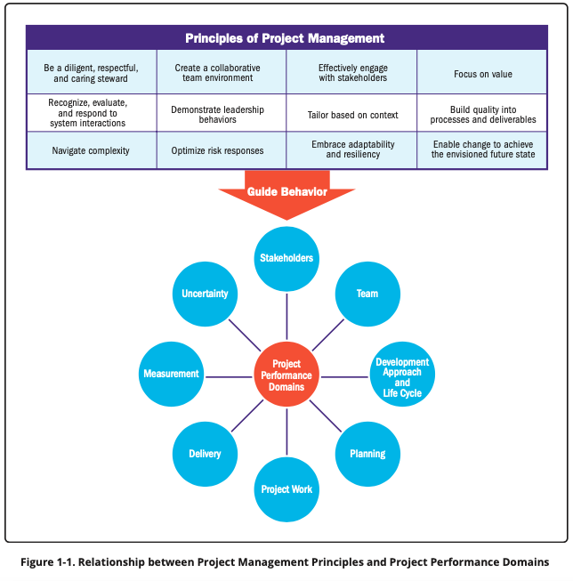

## 1.3 Changes to the PMBoK Guide

## 1.4 Relationship to PMIstandards+

# Project Performance Domains

## 2.1 Stakeholder Performance Domain

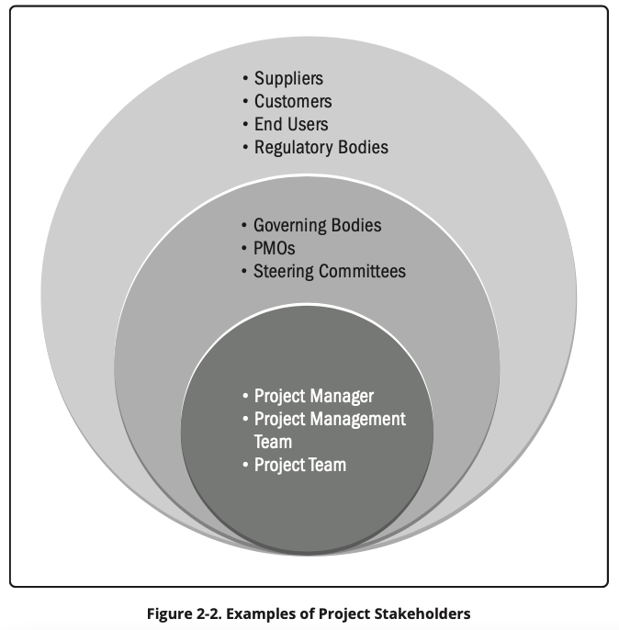

### 2.1.1 Stakeholder Engagement

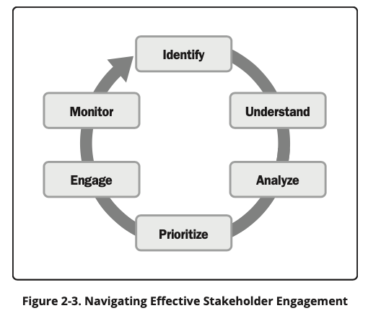

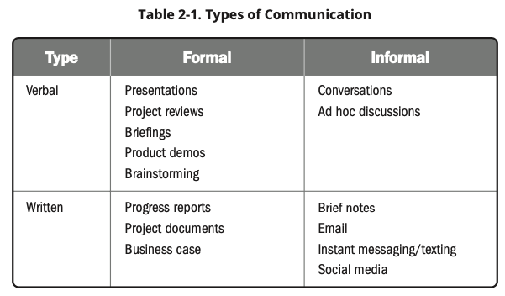

### 2.1.2 Interactions with Other Performance Domains

### 2.1.3 Checking Results

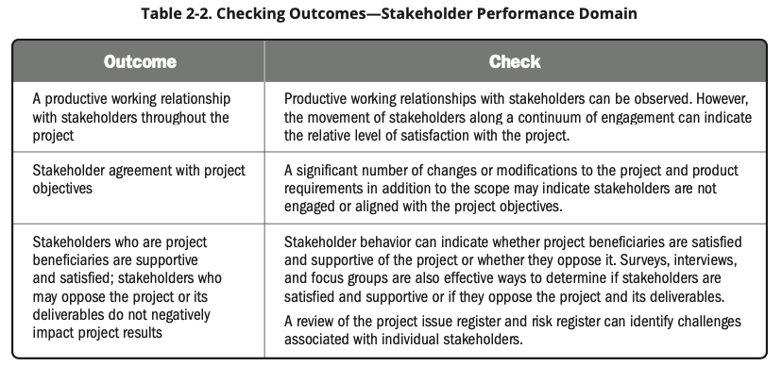

## 2.2 Team Performance Domain

### 2.2.1 Project Team Management and Leadership

### 2.2.2 Project Team Culture

### 2.2.3 High-Performance Project Team

### 2.2.4 Leadership Skills

### 2.2.5 Tailoring Leadership Styles

### 2.2.6 Interactions with Other Performance Domains

### 2.2.7 Checking Results

## 2.3 Development Approach and Life Cycle

### 2.3.1 Development, Cadence, and Lift Cycle Relationship

### 2.3.2 Delivery Cadence

### 2.3.3 Development Approaches

### 2.3.4 Considerations for Selecting a Development Approach

### 2.3.5 Life Cycle and Phase Definitions

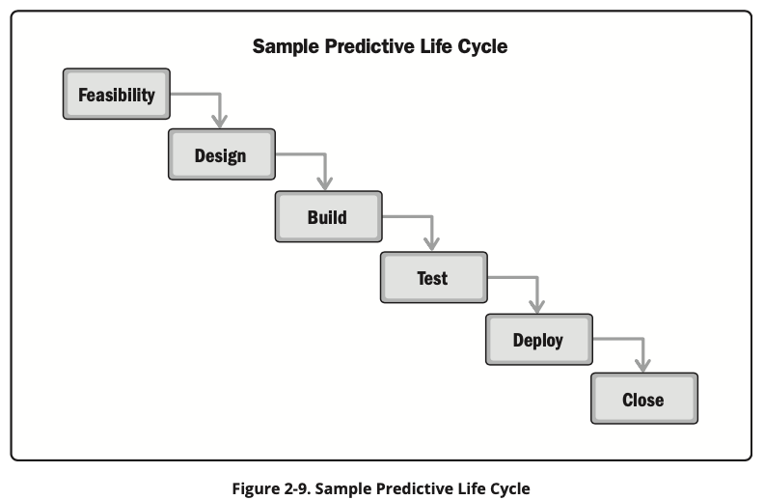

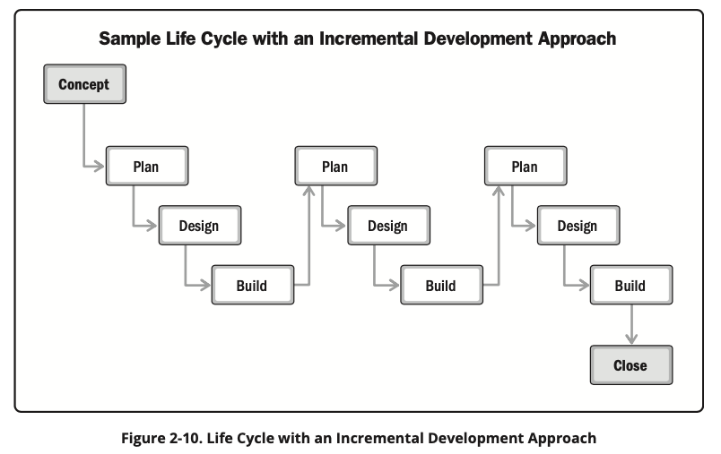

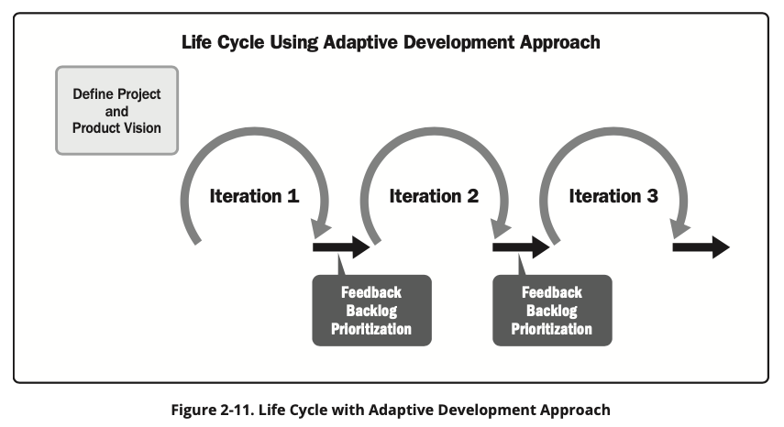

### 2.3.6 Alligning of Delevery Cadence, Development Approach, and Life Cycle

### 2.3.7 Interactions with Other Performance Domains

### 2.3.8 Measuring Outcomes

## 2.4 Planning Performance Domain

### 2.4.1 Planning Overview

### 2.4.2 Planning Variables

### 2.4.3 Project Team Composition and Structure

### 2.4.4 Communication

### 2.4.5 Physical Resources

### 2.4.6 Procurement

### 2.4.7 Changes

### 2.4.8 Metrics

### 2.4.9 Alignment

### 2.4.10 Interactions with Other Performance Domains

### 2.4.11 Checking Results

## 2.5 Project Work Performance Domain

### 2.5.1 Project Processes

### 2.5.2 Balancing Competing Constraints

### 2.5.3 Maintaining Project Team Focus

### 2.5.4 Project Communications and Engagement

### 2.5.5 Managing Physical Resources

### 2.5.6 Working with Procurements

### 2.5.7 Monitoring New Work and Changes

### 2.5.8 Learning throughout the Project

### 2.5.9 Interactions with Other Performance Domains

### 2.5.10 Checking Results

## 2.6 Delivery Performance Domain

### 2.6.1 Delivery of Value

### 2.6.2 Deliverables

### 2.6.3 Quality

### 2.6.4 Suboptimal Outcomes

### 2.6.5 Interactions with Other Performance Domains

### 2.6.6 Checking Results

## 2.7 Measurement Performance Domain

### 2.7.1 Establishing Effective Measures

### 2.7.2 What to Measure

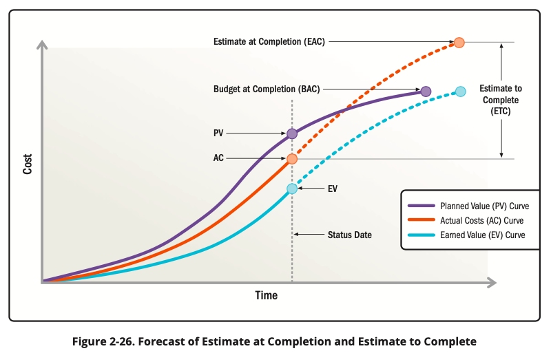

### 2.7.3 Presenting Information

### 2.7.4 Measurement Pitfalls

### 2.7.5 Troubleshooting Performance

### 2.7.6 Growing and Improving

### 2.7.7 Interactions with Other Performance Domains

### 2.7.8 Checking Results

## 2.8 Uncertainty Performance Domain

### 2.8.1 General Uncertainty

### 2.8.2 Ambiguity

### 2.8.3 Complexity

### 2.8.4 Volatility

### 2.8.5 Risk

### 2.8.6 Interactions with Other Performance Domains

### 2.8.7 Checking Results

# Tailoring

## 3.1 Overview

## 3.2 Why Tailor?

## 3.3 What to Tailor

### 3.3.1 Life Cycle and Development Approach Selection

### 3.3.2 Processes

### 3.3.3 Engagement

### 3.3.4 Tools

### 3.3.5 Methods and Artifacts

## 3.4 The Tailoring Process

### 3.4.1 Select Initial Development Approach

### 3.4.2 Tailor for the Organization

### 3.4.3 Tailor for the Project

## 3.5 Tailoring the Performance Domains

### 3.5.1 Stakeholders

### 3.5.2 Project Team

### 3.5.3 Development Approach and Life Cycle

### 3.5.4 Planning

### 3.5.5 Project Work

### 3.5.6 Delivery

### 3.5.7 Uncertainty

### 3.5.8 Measurement

## 3.6 Diagnostics

## 3.7 Summary

# Models, Methods, and Artifacts

## 4.1 Overview

## 4.2 Commonly Used Models

### 4.2.1 Situational Leadership Models

### 4.2.2 Communication Models

### 4.2.3 Motivation Models

### 4.2.4 Change Models

### 4.2.5 Complexity Models

### 4.2.6 Project Team Development Models

### 4.2.7 Other Models

## 4.3 Models Applied Across Performance Domains

## 4.4 Commonly Used Methods

### 4.4.1 Data Gathering and Analysis

### 4.4.2 Estimating

### 4.4.3 Meetings and Events

### 4.4.4 Other Methods

## 4.5 Methods Applied Across Performance Domains

## 4.6 Commonly Used Artifacts

### 4.6.1 Strategy Artifacts

### 4.6.2 Logs and Registers

### 4.6.3 Plans

### 4.6.4 Hierarchy Charts

### 4.6.5 Baselines

### 4.6.6 Visual Data and Information

### 4.6.7 Reports

### 4.6.8 Agreements and Contracts

### 4.6.9 Other Artifacts

## 4.7 Artifafcts Applied Across Performance Domains